**Lecture 2**

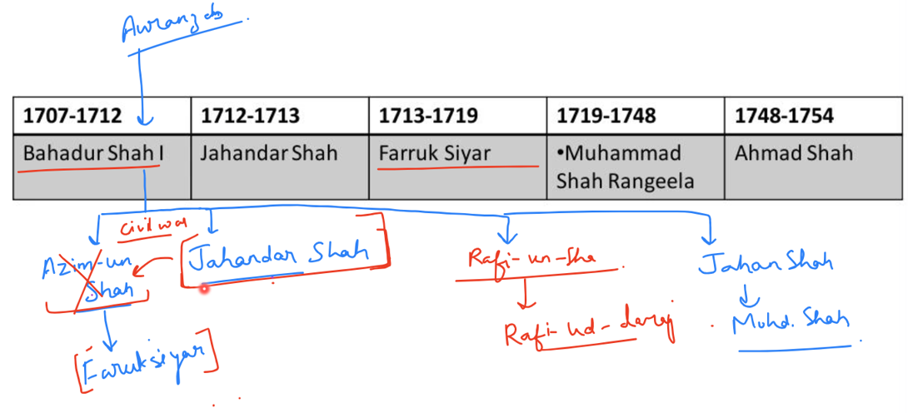

1. **Jahandar Shah : 1712-1713**

* Supported by noble: **Zulfikar Khan** : to kill his brother Azim-un shah to be king and made **Zulfikar Khan** the Wajir.
* He was low credibility person and was a puppet ruler.

**Zulfikar khan** decisions to revive Mughals :

* Conciliated with Hindus; abolished JIZYAH and Pilgrams tax
* Agreed with Rajputs and gave them Subedari of Malwa and Gujarat ,Ajit Singh became governor of Gujrat; gave him title of Mirza Raja Sawai.
* **Chauth and Sardeshmukhi was granted to Marathas.**
* **Started Izarah or revenue farming System :** increased oppression of peasants.

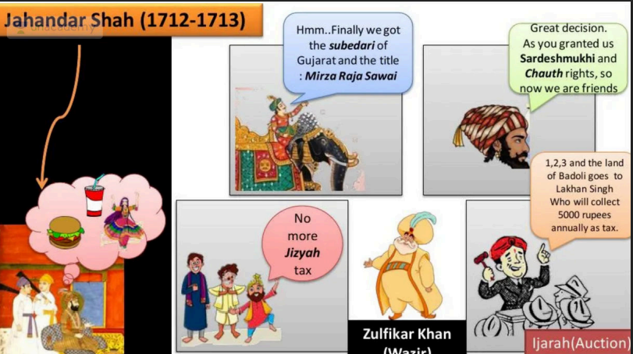

**Wajir in Mughal Court :** PM + Finance Minister

**What is the Ijarah System?**

* "Ijarah" means revenue farming.
* Under this system, land revenue collection was outsourced to the highest bidder.
* The bidder (ijaradars) paid a fixed amount to the state in advance and had the right to collect taxes from peasants in that area.
* Any amount they collected above the fixed amount was their profit.

**✅ Consequences of the Ijarah System (Under Zulfiqar Khan)**

* **Peasant Exploitation**: Ijaradars overtaxed farmers for quick profit. Many left farming and started robbery **which in-turn started to cause internal disturbance.**
* **Agrarian Decline**: No investment in land; farming weakened. **Caused Food Crisis**
* **Revolts**: Harsh treatment led to peasant and zamindar uprisings.
* **Corruption**: Bribery and misuse of power became common
* **Loss of Central Control**: Empire lost direct control over revenue and rural areas.
* **Short-Term Revenue, Long-Term Loss**: Quick income damaged long-term stability.
* **Farukh Siyaar : Supported by Syed Brothers killed Jahadar shah and made Zulfikar khan to flew. He was son of Azim-ul-shah.**

1. **Farukh Siyaar : (1713-1719)**
   * Farrukh Siyar owed his victory to the Sayyid brothers, **Abdullah Khan** and **Husain Ali Khan Baraha**, who were therefore given the offices of **wazir** and **mir bakshi** respectively. They were called “**King Makers**”
   * **Mir Bakshi** : Military Commandor in chief

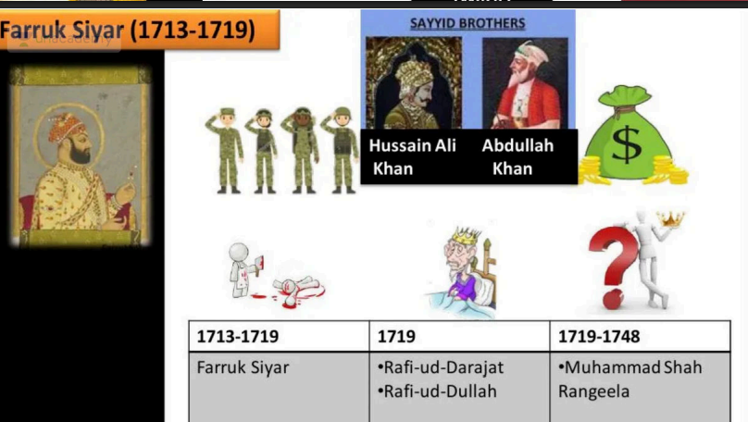

**Decisions by Sayyed brothers:**

* Conciliaton with Hindus; abolished pilgrim tax
* Gave high positions to Rajput rulers like Ajit Singh and Jai Singh
* Alliance with Churaman
* Granted the right to collect also **for chauth and sardeshmukhi** to Maratha ruler Shahuji : which gifted 1500 soldiers to Mughals in return
* **Central income declined due to spread of revenue farming (ijarah) -> no salary for soldiers->they became undisciplined.**

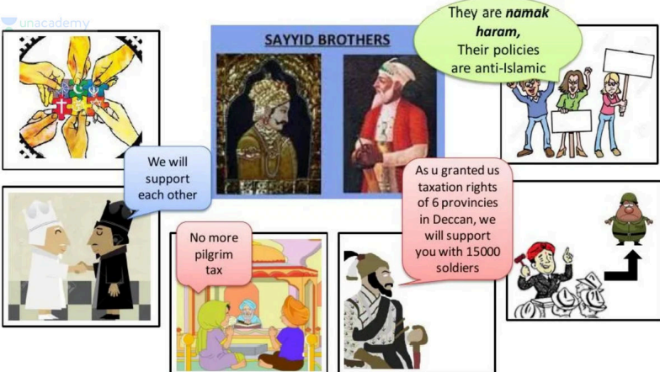

* The anti- Sayyid nobles were supported by Emperor **Muhammad Shah** In 1720**, Haidar Khan killed Hussain Ali khan on 9 October 1720 and Abdullah Khan was defeated near Agra later.**

1. **Rafi-ud-Darajat and Rafi-ud-Dullah :**

* **Saiyid Brothers Killed Farruk Siyar also and appointed these new minor kings and they died young.**

1. **Muhammad Shah Rangeela : (1719-1748)**

* Weak-minded and frivolous and over-fond of a life of ease and luxury.

neglected the affairs of state

* fell under the evil influence of corrupt and worthless flatterers and intrigued against his own ministers

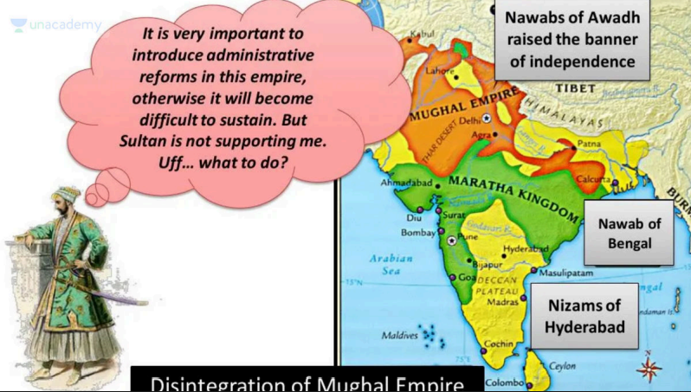

* **1724,Nizum-ul-Mulk,** the most powerful noble of the time who was Nizam of Hyderabad but was called Delhi and promoted to **WAZIR** by Rangeela, decided to leave the Emperor and his Empire to their fate and to strike out on his own. marched south to setup **Independent Hyderabad in practice as successor state** in the Deccan which didn’t cut entire ties with Mughals.
* Many other zamindars, rajas, Subedars and nawabs of many states raised the banner of rebellion and independence under his rule which was start of the physical disintegration of Mughal territory now.
* **Attack of Nadir Shah of Afghanistan (Battle of Karnal) in 1738 :** where he defeated Mohammad Shah and became **king of Delhi** for few months.

**He took Peacock Throne with him, famous Kohinoor and territories west of Indus and handed over the throne back to Mohammad Shah.**

* **Nizam vs Nawab difference :**Nizam represent Mughal Crown in Deccan. They are like **Viceroys.**  
  Nawabs are **governors** or **subedars or provincial heads.**

1. **Mughals after Mohmmad Shah Rangeela and important events in their reign : (Read from Pictures)**

* The British were granting a pension to **Akbar II**. In hopes of getting it increased, he conferred **the title of 'Raja'** on **Raja Ram Mohan Roy**, requesting him to advocate for the pension hike with the British in London.

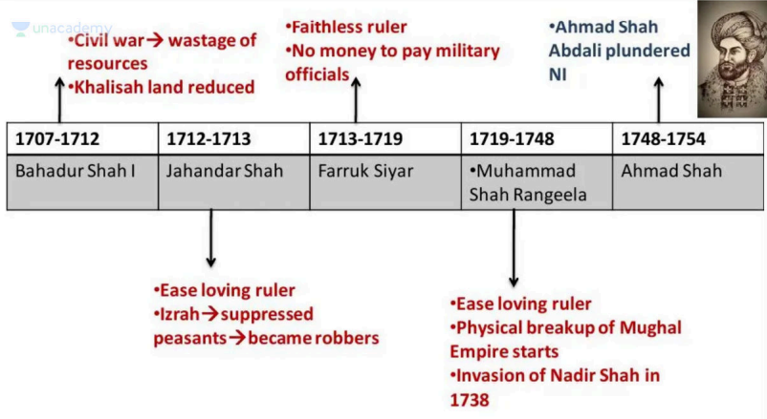

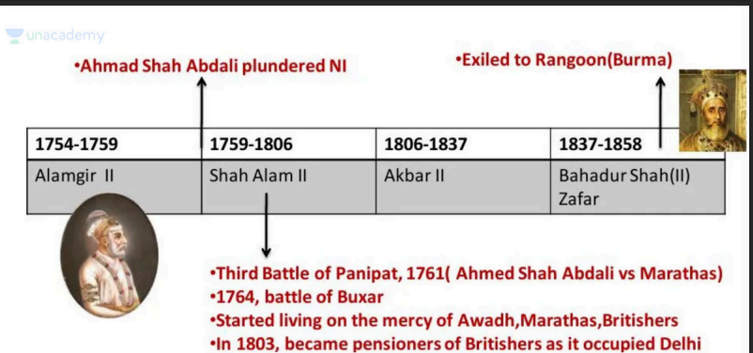

**“In fact, the continuation of the Mughal monarchy after 1759 , when it**

**had ceased to be a military power, was due to the powerful hold that**

**Mughal dynasty had on the minds of the people of India as the symbol**

**of the political unity of the country.”**

**-Bipin Chandra**

1. **Rangeela’s regn and rising regional aspirations :**

New Regional States formed in India from Rangeela’s time.

During the decline of **the Mughal Empire (especially after Aurangzeb’s death in 1707)** and more rapidly in **Rangeela’s reign**, the empire fragmented. **Territories either declared independence**, **became rebellious, or drifted outside Mughal influence.** These are commonly grouped into:

**✅ Successor States**

These were originally part of the Mughal Empire and formed independent dynasties while still acknowledging the Mughal emperor nominally (**for legitimacy**). These states continued using Mughal titles and minting coins in the emperor's name for a while, **but were de facto independent**.

1. **Hyderabad**

* The state of Hyderabad was founded by **Nizam-ul-Mulk Asaf Jah** in 1724.
* Mir Qamar-ud-din, disillusioned by **Muhammad Shah Rangeela**—who had appointed him as Wazir of Delhi—returned to the Deccan and assumed the title **"Nizam-ul-Mulk,"** initiating de facto self-rule while nominally recognizing the Mughal emperor for legitimacy.
* He displaced the existing local Subedars of the Deccan, established hereditary rule under the Asaf Jahi dynasty, and laid the foundation for the Nizams of Hyderabad.
* The Nizams did not oppose British authority and often allied with them. Hyderabad remained a princely state and was not annexed to India until 1948 during **Operation Polo**, a year after independence.

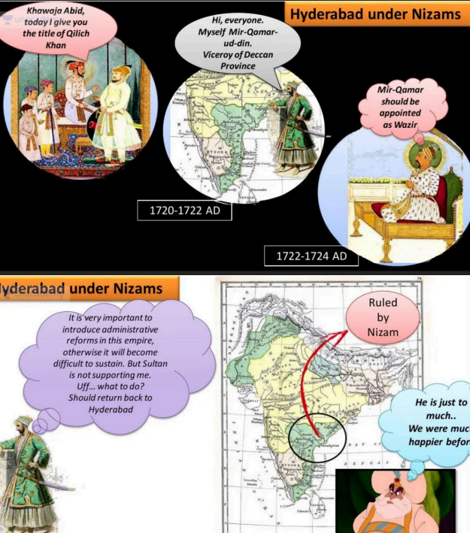

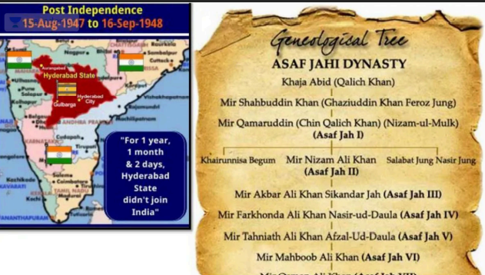

1. **Bengal –** Controlled by Murshid Quli Khan from 1717**.**
2. **Awadh (Oudh) –** Established by Saadat Khan Burhan-ul-Mulk in 1722.

**⚔️ Rebellious States / Breakaway Kingdoms**

These were military revolts or secessionist movements against Mughal control:

1. **Marathas –** Rose under Shivaji in the 17th century, expanded massively in 18th century.
2. **Jats** – Rebellions in Mathura–Agra region, led by Churaman and later Suraj Mal**.**
3. **Sikhs –** Under Guru Gobind Singh, Banda Singh Bahadur, and eventually formed the Khalsa confederacy.
4. **Rohillas (Afghans in Rohilkhand) –** Semi-independent in the 18th century.

These were not administrative divisions but ethno-political-military uprisings that carved out their own regions.

**🚫 Out-of-Influence / Independent Kingdoms**

These were never fully integrated into the Mughal empire or withdrew early from Mughal control:

1. **Rajputana States –** E.g., Mewar, Marwar, and others. Some had alliances with Mughals but remained largely autonomous.
2. **Mysore –** Under Hyder Ali and Tipu Sultan; southern Deccan power.
3. **Travancore, Cochin, and other southern principalities.**
4. **Assam (Ahom Kingdom) –** Resisted Mughal control successfully.
5. **Afghanistan** – Lost to Ahmad Shah Abdali/Durrani after the mid-18th century.
6. **Punjab (under Sikhs) –** Became completely independent under Maharaja Ranjit Singh by early 19th century.

**Summary Table**

| **Category** | **Examples** |
| --- | --- |
| **Successor States** | Bengal, Awadh, Hyderabad |
| **Rebellious States** | Marathas, Jats, Sikhs, Rohillas |
| **Out-of-Influence** | Rajputs, Mysore, Assam, Punjab, Afghanistan |

**01:14:33**

**ii . Carnatic Region : - Nawab of carnatic region started to act freely : Saadatullah Khan later : his nephew Dost ali ruled. (heridotry postn made) - They are called Nawabs of Arcot**

**01:18:00**

**iii. Bengal Province ( WB + Bangladesh + odisa +Chattisgardh + jharkhand) - Murshidabad was capital - Murshid Quli Khan was Deewan of Bengal (Finance minister was called Diwan) who was made nawab of bengal who made it heridotory --- - They reorganized the finances of Bengal (Revived the econmy of Bengal if couldnot of Mughal empire) ---**

**01:26:51**

**Basics - Types of Lands -based on Taxability and uses - Based on fertility ---------------------- Agriculture Reforms : Bengal rules encouraged for cultivation on Banjar Lands by 1. First Converting all Jaagir land into khalisa land ( removed powers of jaagirdar frst to collect tax) 2. Gave Loans called tacccavi to farmers 3. Made provisions for farmers to not to pay tax for few years for banjar land cultivation 4. Appointed jaagirdaar later then to collect tax on lands. the land was made in auction under izhara system and appointed jaagirdar**

**01:34:33**

**They encouraged Trade and commerece - Made thanaas from place to place -Collected Custom duty as nawab of bengal from traders - Traders gave good tax from their good earning**

**01:35:55**

**iv. AWADH : (UP now almost) - Saadat khan burhan ul mulq a. made army strong b. Gave taccvi loans as bengal c, Made awadh army striong d. Carried independent rule and made his post heridiotory**

**JUMP TO 01:45:40**

**- Safdar Jung secular handicraft promoted high-morality as married once**

**01:47:10**

**Famous Awadh Nawabs to remember**